**Brief explaination.**

My webpage is a webpage to a proyect im doing in BBDD in which is a fruit store. I´ve done de index page(it is the home page) in which I explain what is my company. It’s a simple webpage with header and footer.

I also have a 404 wepage because I didn’t have time to do all the webapges, but I have a login page, a register page and a contact webpage. There are some icons that got imported that is called ion icon, those are linked to external webapges such as Instagram, twitter…

All my pages mix css and bootstrap, login form is made only with css and register and contact for are made with bootstrap. I hope you like my proyect.

URL of the proyect: https://informatica.iesquevedo.es/dam1/DAM-AlanMikolajczyk/index.html

URL of an external host: <https://defectofruta.000webhostapp.com/index.html>

VALIDATION IMAGES

HTML VALIDATORS

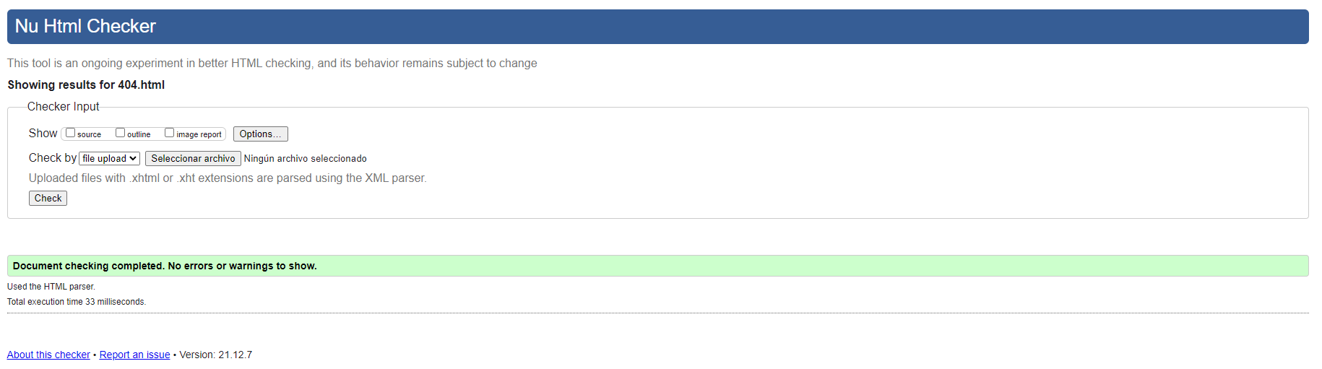

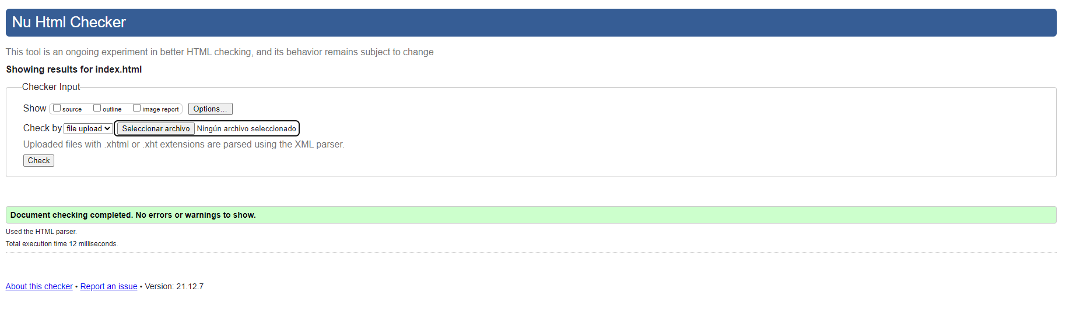

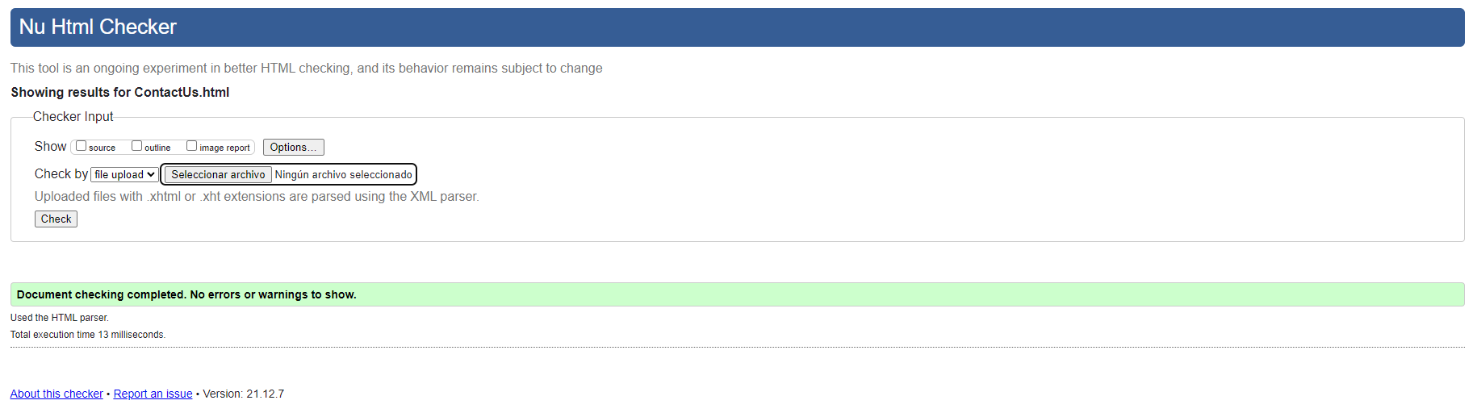

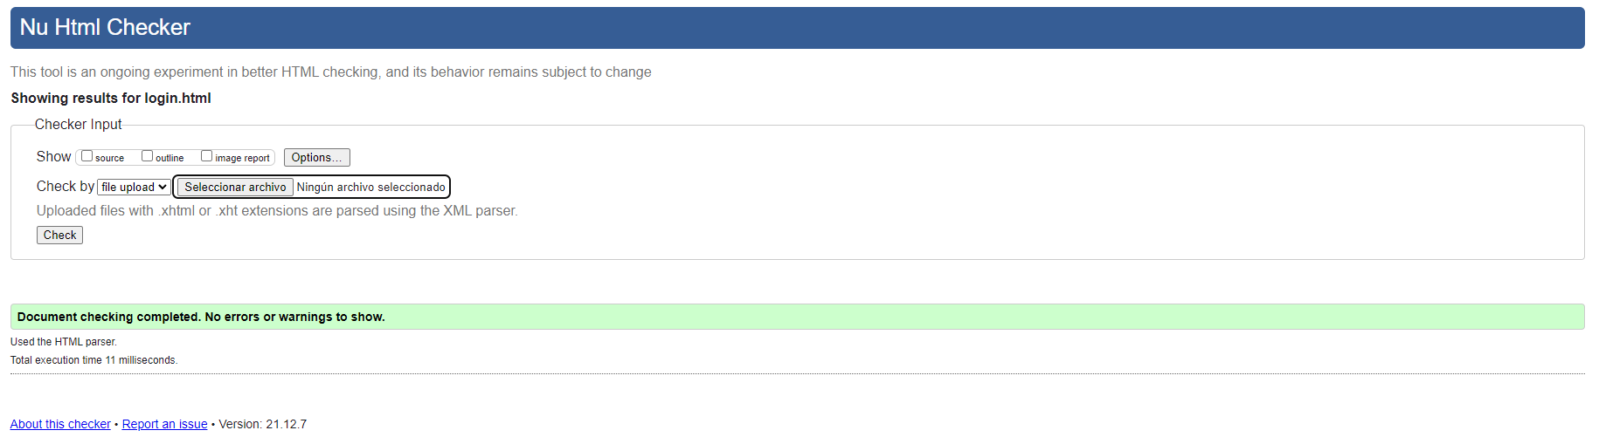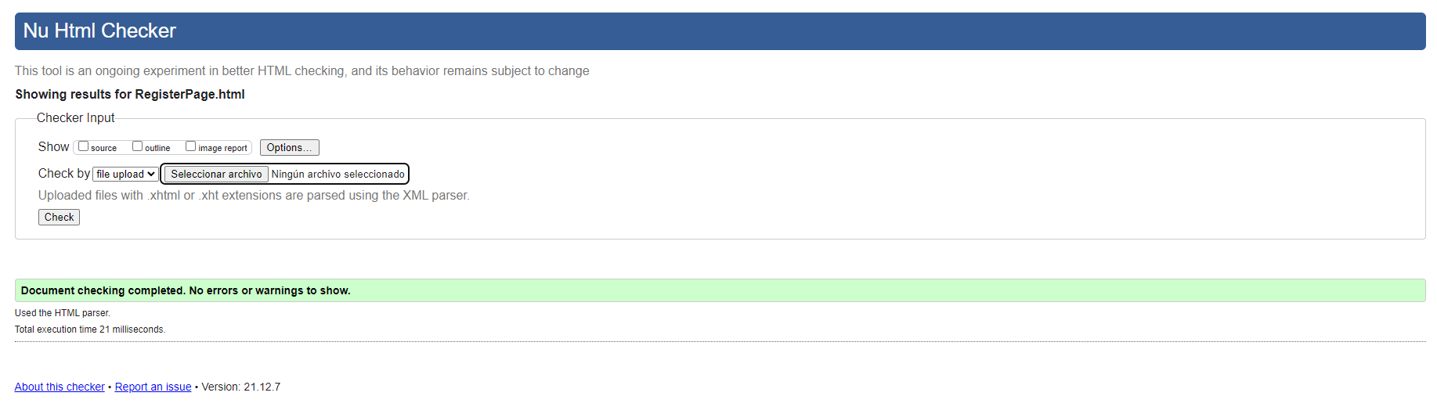

CSS VALIDATORS

